Expno:6DeterminationandplottingofCapacitanceofparallelplatecapacitorin threedifferentdielectricmediumwithspecificarea,dielectricthicknessandvarious dielectricconstant.

Aim:
Towriteprogram forcapacitanceofparallelplatecapacitorinthree differentdielectric media using SCILAB.

Softwarerequired:
- SCILAB version6.0.1

Theory: Program:

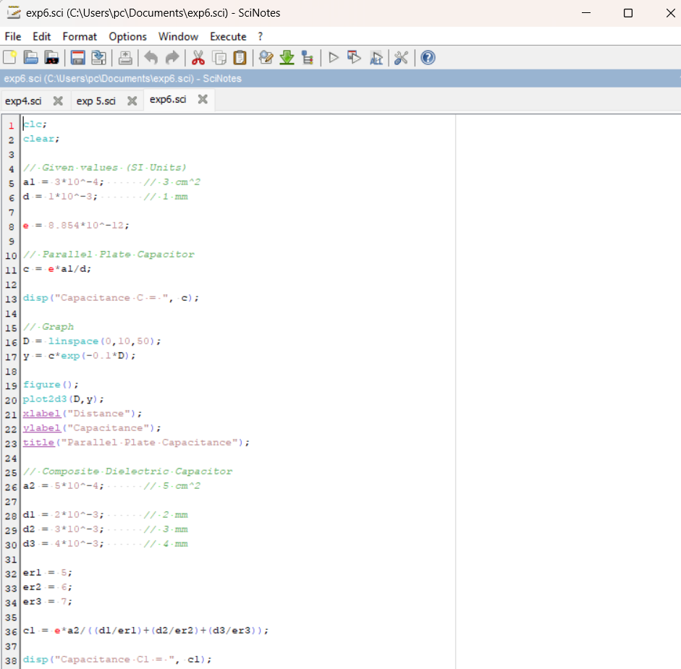

Output:

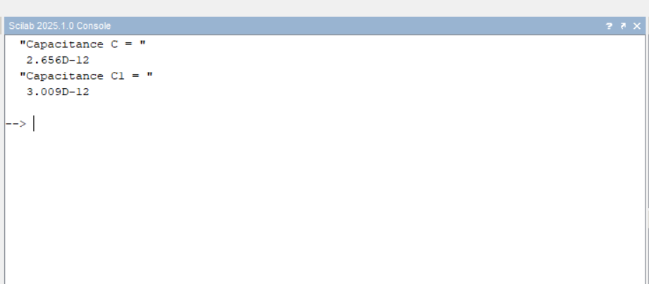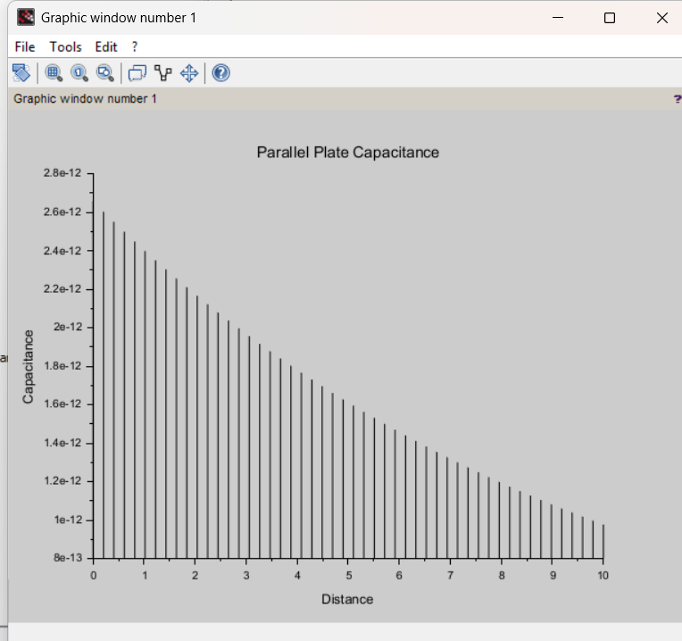

Calculation:

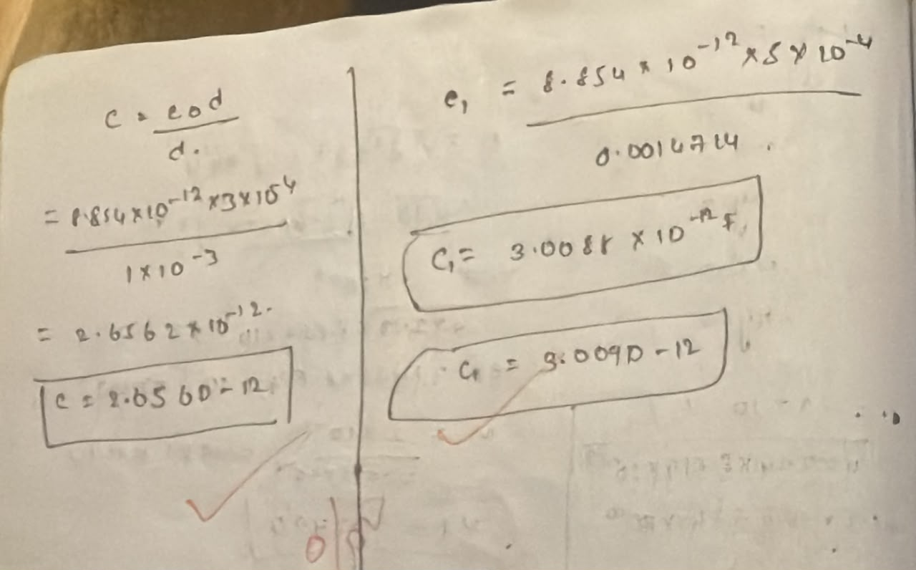
Case1:
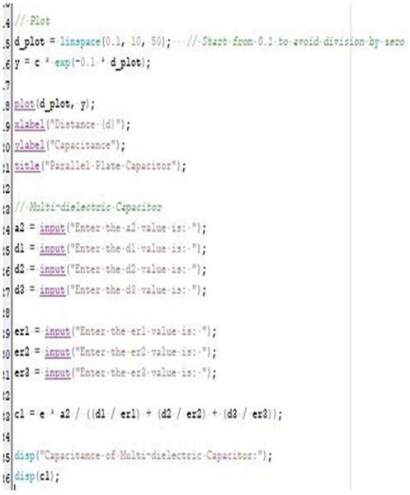

Output:

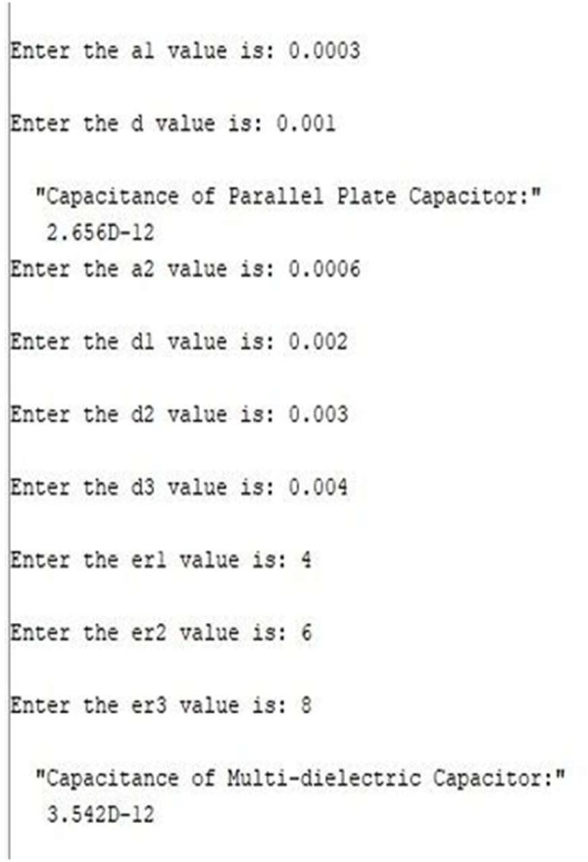
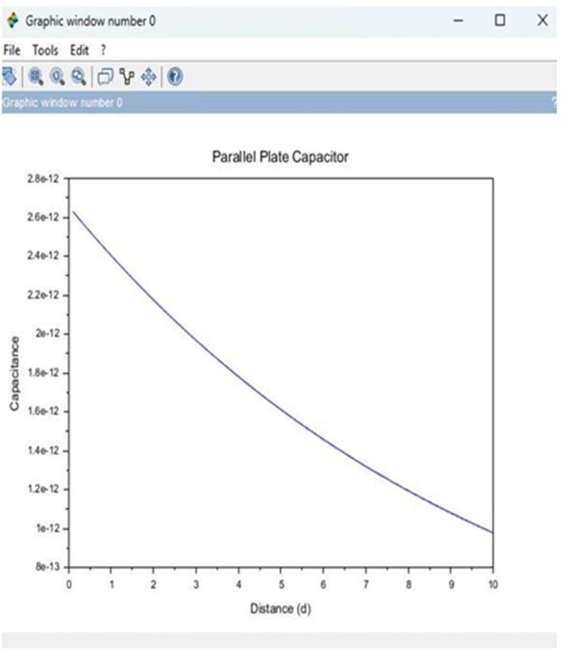

Case2:

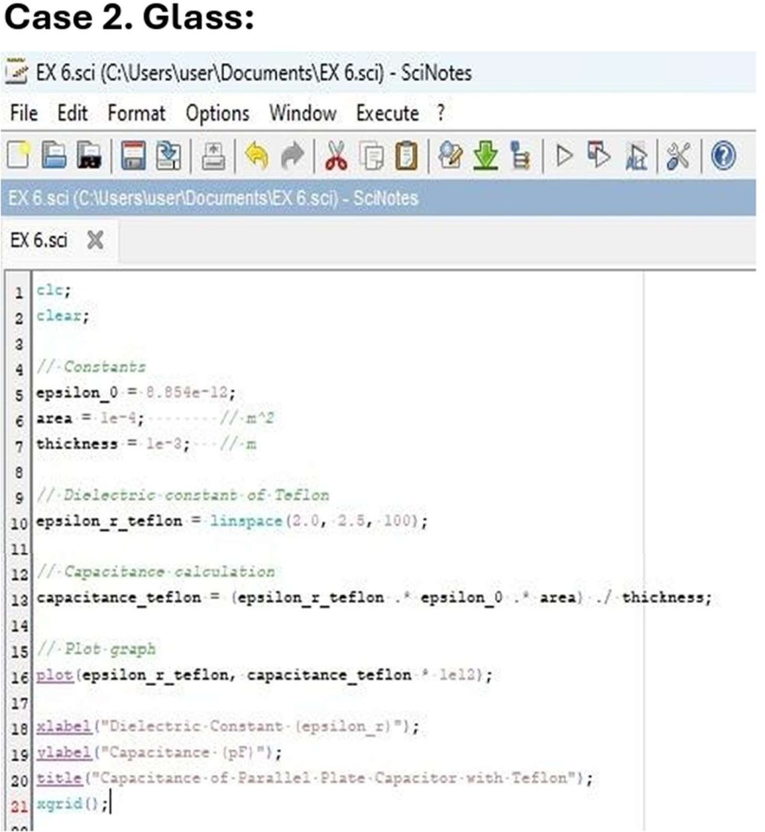
Output: Case3:
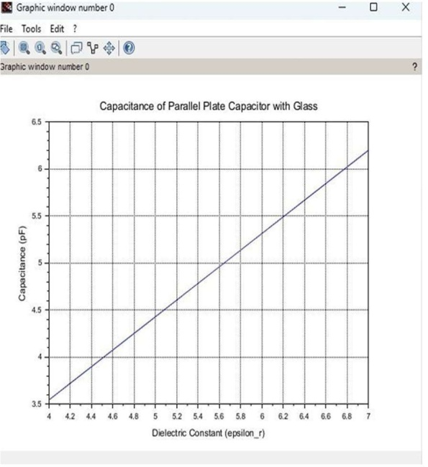

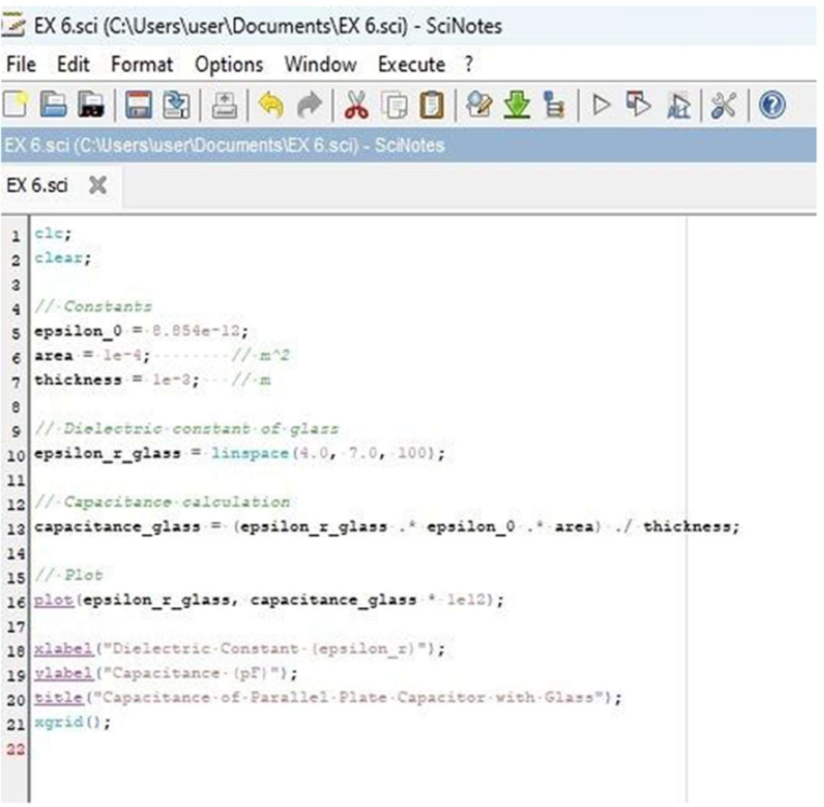

Output:
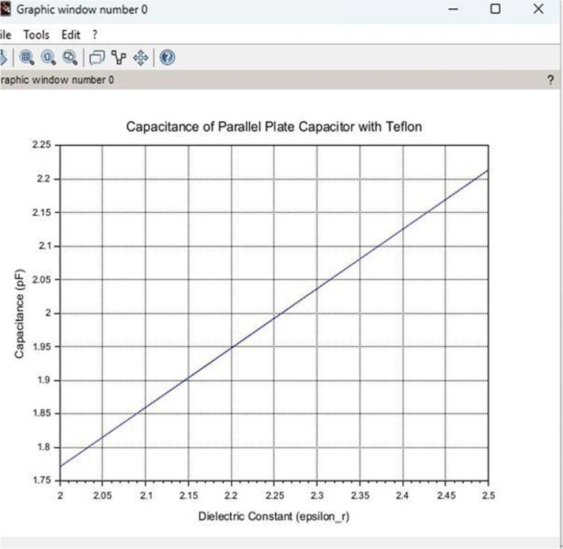
Result:Thustheprogramwasverifiedforcapacitanceofparallelplatecapacitorin three different dielectric media using SCILAB was successfully.

